SPI and STM32-LIS3DSH accelerometer sensor communication with SPI

Full duplex:master and slave can receive and trasmit data

Half dublex: **Half duplex** unidirectional or write only mode could be used when master don't need data from slave.

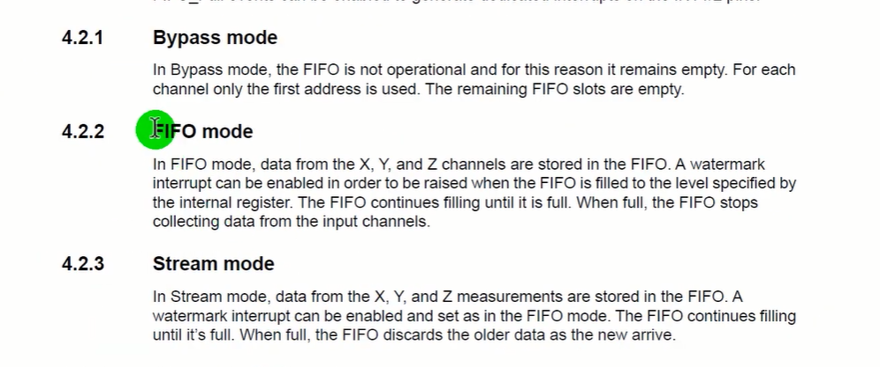

There are 3 modes

In stream mode datas are measured and takes continously

In FIFO mode data pulls one time than stop mode starts

STM32 part

1. Create new project and don’t change any cloclk conf.
2. Go to connnectivity and select full dublex master mode

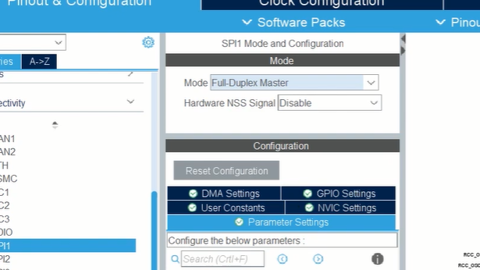

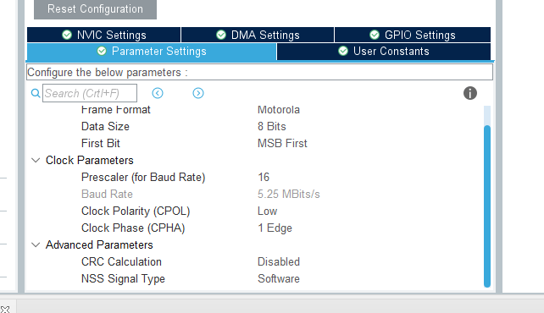

4)set pe3 as GPIO output

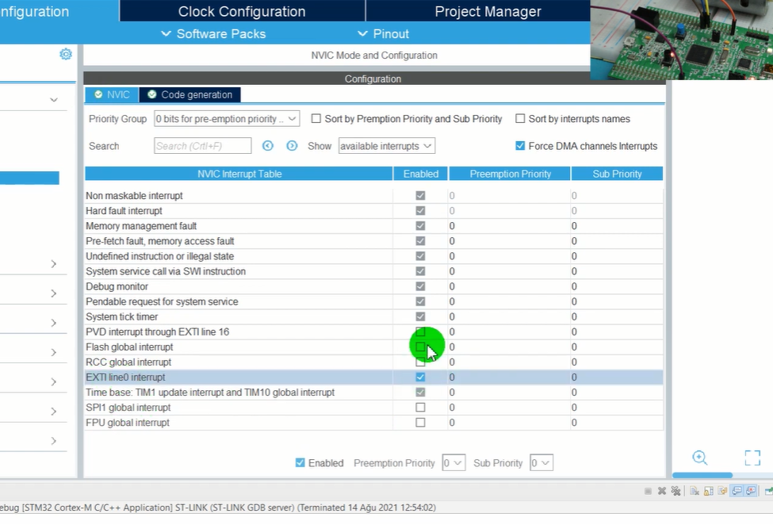

5)In Nvic tab enable EXTI line 0 interrupt

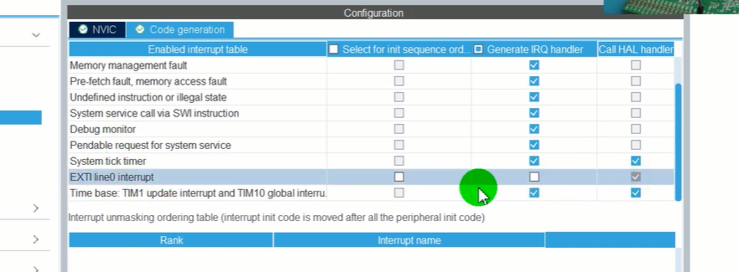

6)EXTI line0 interrupt Code generation part uncheck we will wrtie this IRQ handler

7)set pins PD12,PD13,PD14,PD15

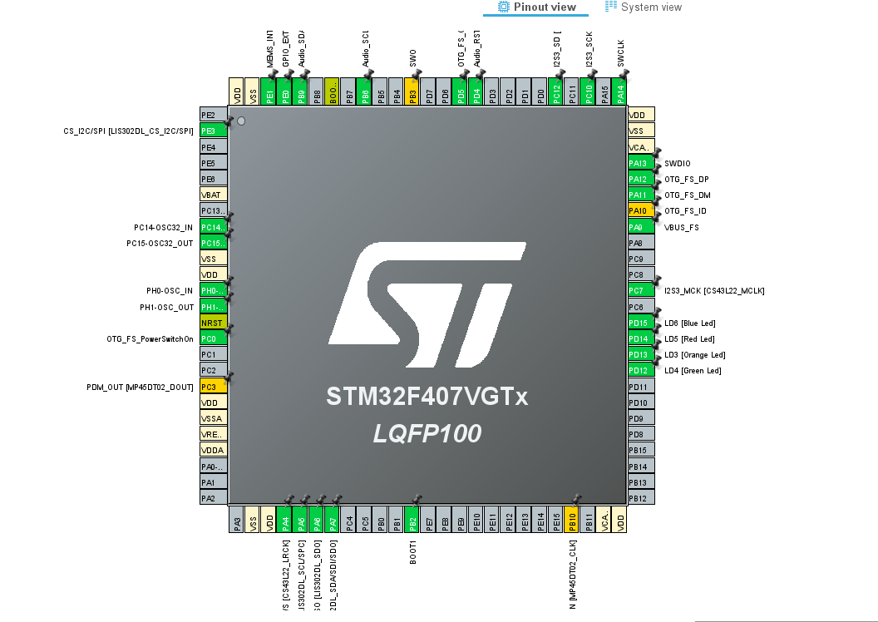

Ü